12/12/2025

IT Technical Support
Ticket Analysis Using MYSQL Workbench 8.0
Jeremiah Mendoza

Project Overview:
The purpose of this project was to analyze IT Help Desk ticket data to evaluate operational performance, identify workflow bottlenecks, and assess service level effectiveness. Using SQL, I explored ticket resolution behavior, agent performance, and SLA compliance to generate actionable insights that could help improve support efficiency and customer satisfaction.
This project attempts to simulate real-world IT service desk analytics.

Introduction:
To better understand how the IT help desk supports the organization’s goals, I created a set of data questions focused on operational performance and efficiency. The purpose of this analysis was to identify weaknesses in the current support process while also exploring opportunities to improve team performance and service delivery.

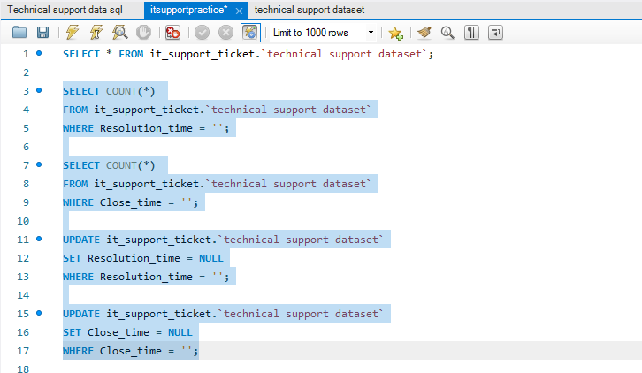
Before executing my queries, I encountered an issue converting the Resolution_time and Close_time fields to a datetime data type. This occurred because several rows contained blank values in these columns. To resolve this, I first identified how many records contained blank values and then standardized those entries by converting them to NULL. This then allowed the datetime conversion to be applied.

Data Insights:
Finding the total average ticket completion time in hours
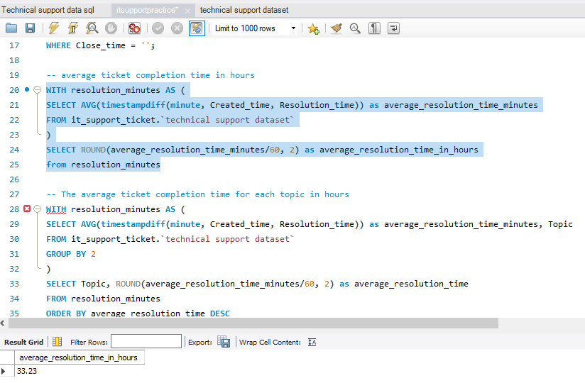
Explanation: This metric establishes an overall baseline for help desk performance by measuring how long tickets take to resolve on average. It provides an indicator of operational efficiency and serves as a reference point for SLA evaluation and process improvement efforts.

The average ticket completion time for each topic in hours
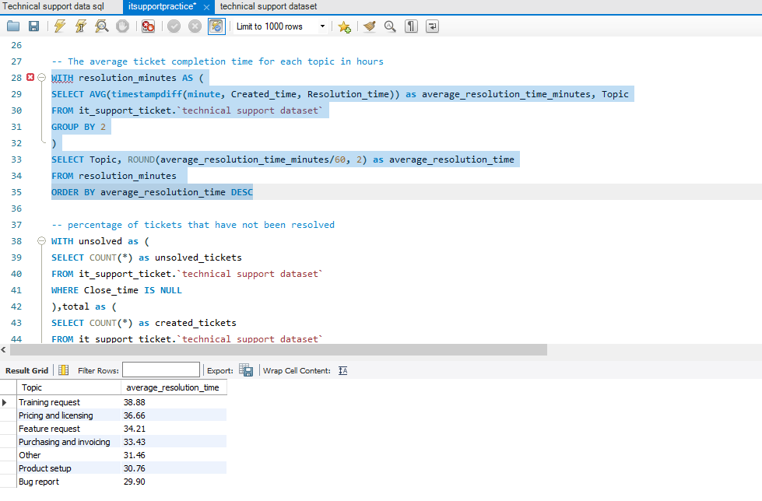
Explanation: This analysis compares resolution times across ticket topics to identify issue types that consistently require more effort or time to resolve. These insights help prioritize process optimization and resource allocation toward the most time intensive problem areas.

The total percentage of tickets that have not been resolved
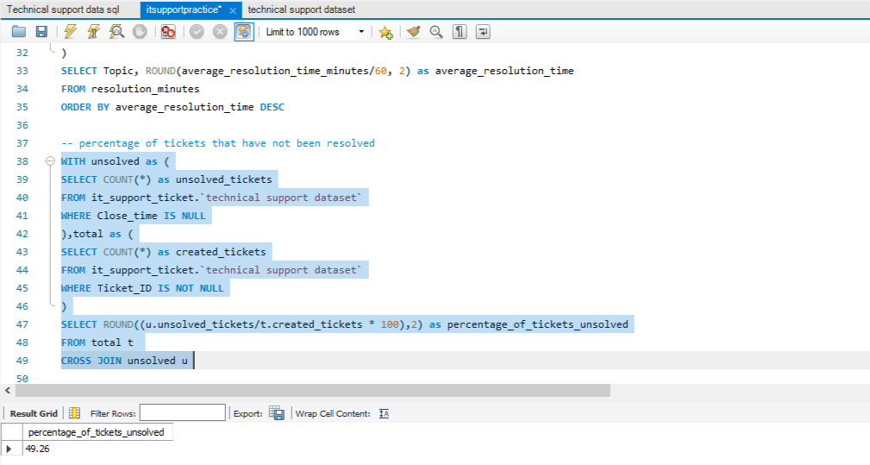
Explanation: This metric quantifies the size of the unresolved ticket backlog and highlights potential risks to service quality. A higher unresolved rate may indicate capacity constraints, escalation gaps, or recurring issues that require deeper investigation.

The top three product and topic groups that make up the unresolved tickets
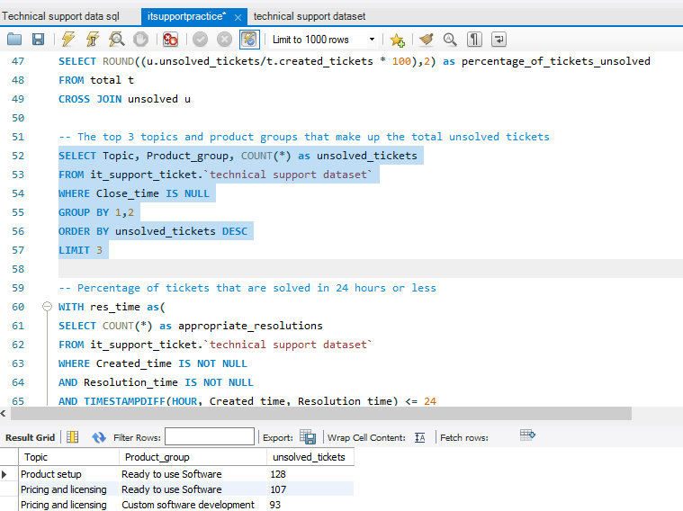
Explanation: This analysis isolates the product and topic combinations most responsible for unresolved tickets. Identifying these high impact areas helps target preventive fixes, and workflow improvements to reduce repeat backlog.

The percentage of tickets that are solved in 24 hours or less
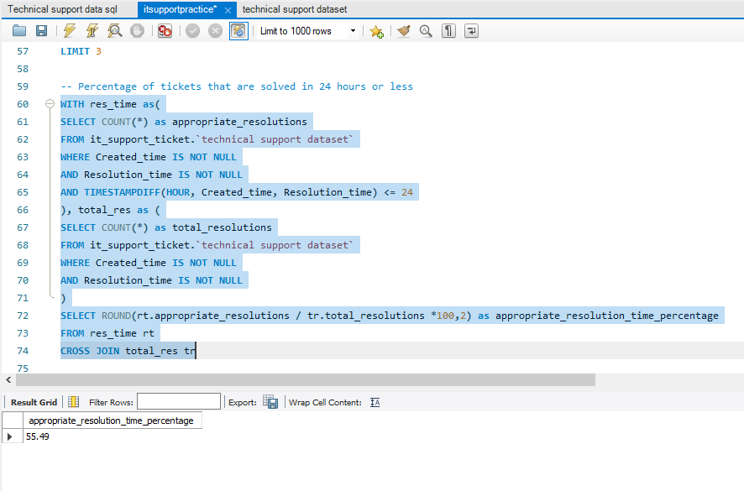
Explanation: This metric measures SLA adherence by evaluating how frequently tickets are resolved within the 24 hour target window. It provides a clear indicator of responsiveness and operational reliability from the customer’s perspective.

The top 2 agents per agent group based on individual average feedback
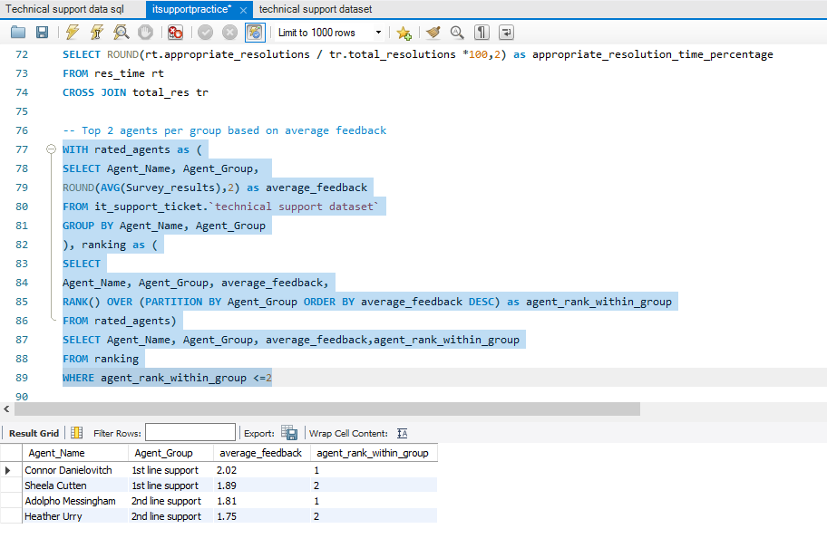
Explanation: This analysis ranks agents within each group based on average customer feedback to identify top performers. These results help establish performance benchmarks and highlight best practices that can be shared across teams.

The three highest agent percentages that do not fall within SLA standards
(total resolved tickets / tickets that were not resolved in timely manner)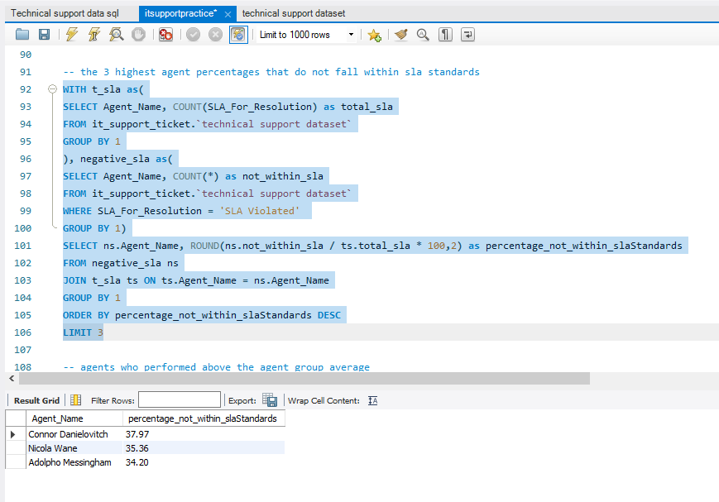
Explanation: This analysis highlights agents with the highest proportion of tickets exceeding SLA thresholds. The findings help identify potential workload imbalances, process inefficiencies, or training opportunities that may be impacting timely resolution.

Agents who performed above their group average in customer feedback
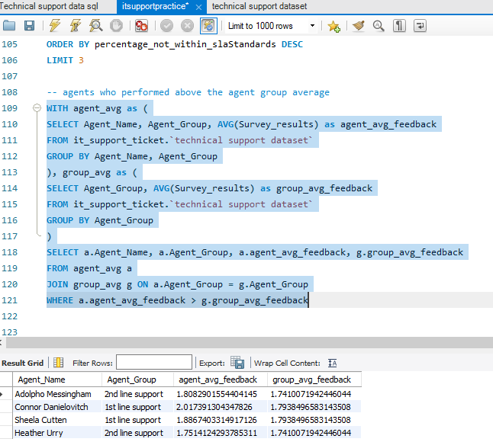
Explanation: This query identifies agents who consistently outperform their group averages in customer satisfaction. These individuals represent strong service delivery standards and may serve as mentors, trainers, or candidates for expanded responsibilities.
Determining whether a higher satisfaction rate correlates with faster resolution time
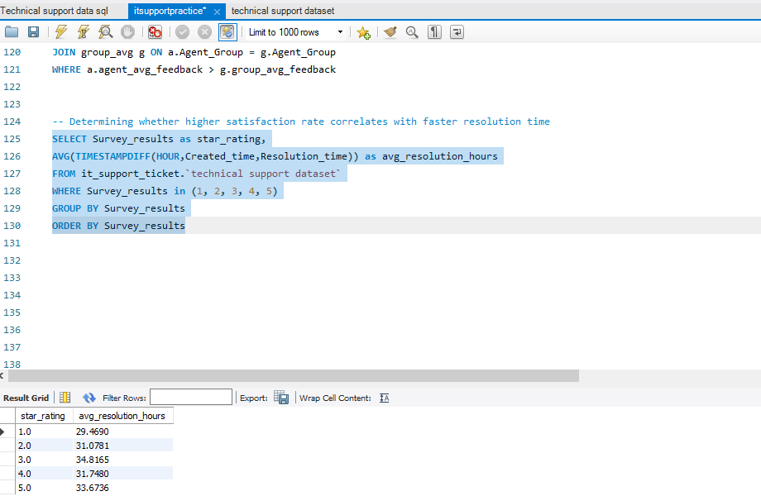
Explanation: This analysis evaluates the relationship between resolution speed and customer satisfaction to determine whether faster ticket closure contributes to better user experiences. The results support data driven decisions around prioritization, staffing, and service quality initiatives.

Final Thoughts:
Through examining ticket resolution timelines, SLA compliance, issue concentration, and agent-level performance. This project attempts to evaluate both efficiency metrics and service quality indicators to provide a well rounded view of how the support function performs on a day to day basis. The findings show that while overall ticket resolution performance meets baseline expectations, meaningful variability exists across issue types, products, and individual agents.
A closer review of unresolved and late resolved tickets reveals that a limited number of issue categories and product areas account for a disproportionate share of service delays. This concentration suggests that many performance challenges are systemic rather than isolated. Addressing these recurring problem areas has the potential to reduce ticket volume, shorten resolution times, and alleviate operational strain on support teams.
The agent level analysis further highlights differences in resolution efficiency and customer satisfaction outcomes. Certain agents consistently outperform both SLA benchmarks and group level averages, indicating the presence of effective practices that could be standardized across teams. Conversely, agents with higher SLA percentages may benefit from additional training, workload rebalancing, or process support. These findings reinforce the value of using data driven performance monitoring to promote consistency and continuous improvement.
From a business perspective, the results underscore the importance of aligning support resources with demand patterns and performance risk areas.

